Fundamentals Of Data Science-DSA0410
Lab Experiments

M. Ranga rao
192472376

Experiment-11
Program:
import matplotlib.pyplot as plt

days = [1, 2, 3, 4, 5, 6, 7]
sales = [120, 150, 170, 160, 180, 200, 190]
plt.plot(days, sales)
plt.xlabel("Day")
plt.ylabel("Sales")
plt.title("Sales Over a Month - Line Plot")
plt.show()
plt.scatter(days, sales)
plt.xlabel("Day")
plt.ylabel("Sales")
plt.title("Sales Over a Month - Scatter Plot")
plt.show()
plt.bar(days, sales)
plt.xlabel("Day")
plt.ylabel("Sales")
plt.title("Sales Over a Month - Bar Plot")
plt.show()

Output:
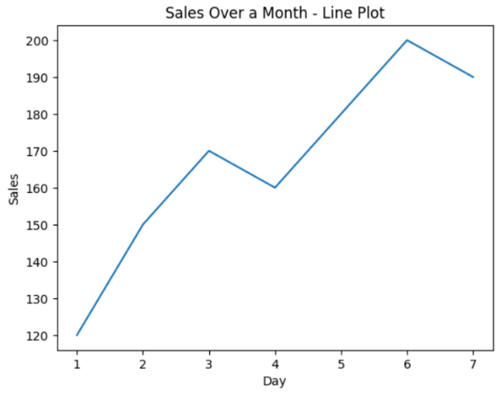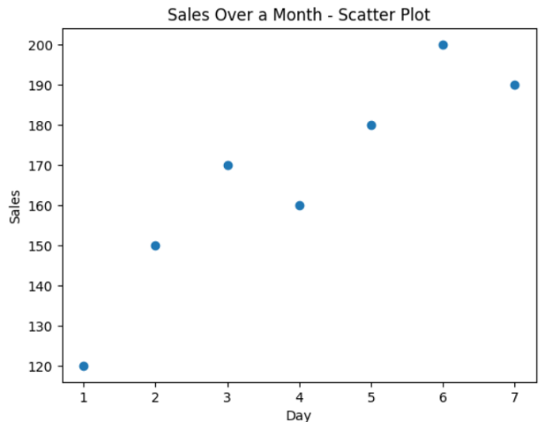

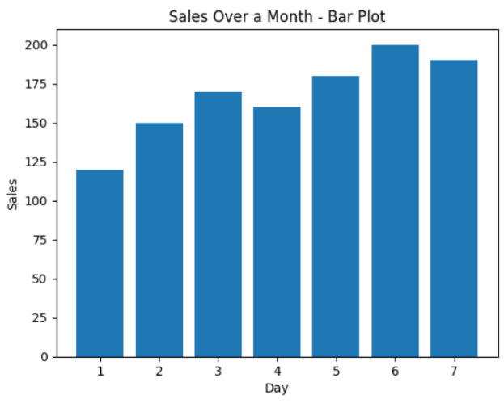

Experiment-12
Program:
months = ["Jan", "Feb", "Mar", "Apr", "May"]
temperature = [22, 25, 28, 30, 35]
rainfall = [50, 40, 30, 20, 10]
plt.plot(months, temperature)
plt.xlabel("Month")
plt.ylabel("Temperature (°C)")
plt.title("Monthly Temperature")
plt.show()
plt.scatter(months, rainfall)
plt.xlabel("Month")
plt.ylabel("Rainfall (mm)")
plt.title("Monthly Rainfall")
plt.show()

Output:
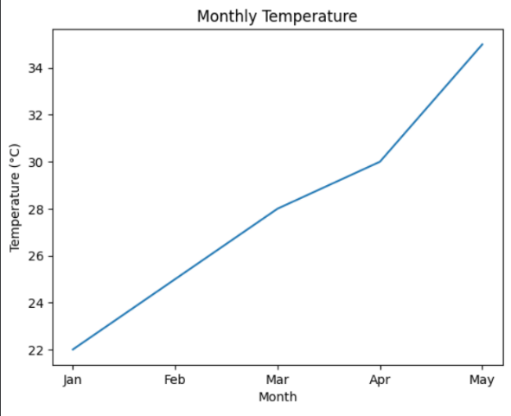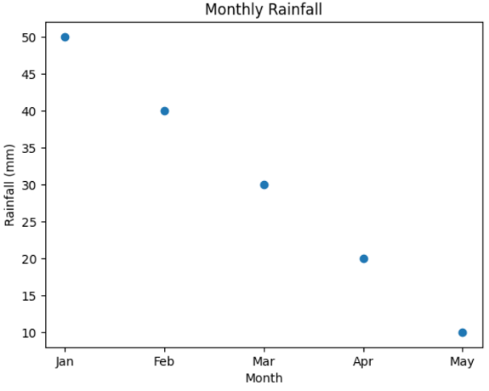

Experiment-13:
Program:
from collections import Counter
with open("sample_text.txt", "r") as file:
text = file.read().lower()

words = text.split()
word_frequency = Counter(words)
print(word_frequency)
Output:
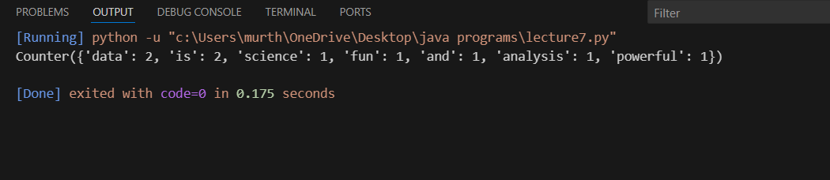

Experiment-14:
Program:
import pandas as pd

sales_data = pd.DataFrame({
"CustomerAge": [22, 25, 22, 30, 25, 22, 35]
})
age_frequency = sales_data["CustomerAge"].value_counts()
print(age_frequency)
Output:
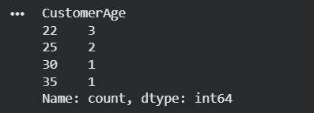

Experiment-15:
Program:
likes = [10, 20, 10, 30, 20, 10, 40]
from collections import Counter
like_frequency = Counter(likes)
print(like_frequency)
Output:
